## Solutions Exercise 03: Making a medical questionnaire (2) - basic field and instrument operations

* Renaming the first survey instrument to “Patient information”:

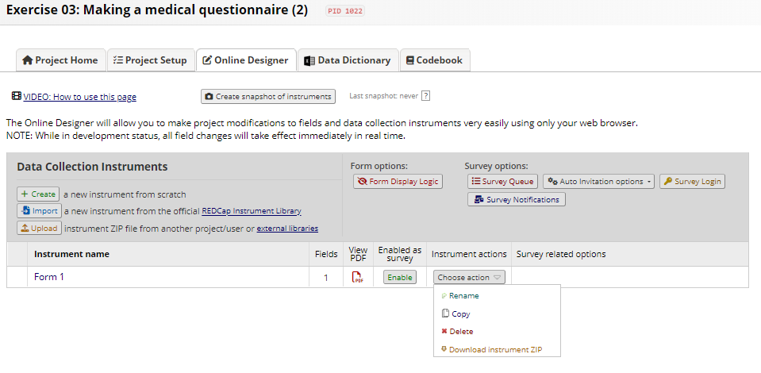

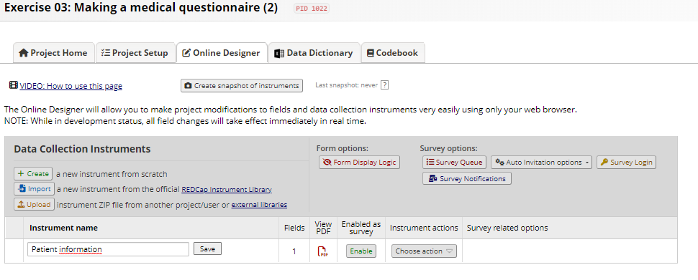

* Create the “Doctor visit form”:

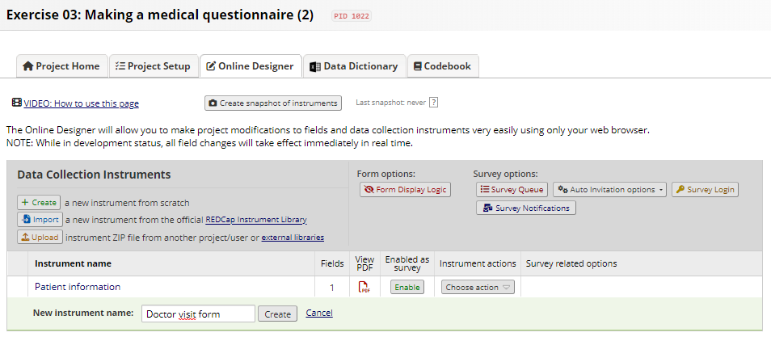

* Rename the Record ID field

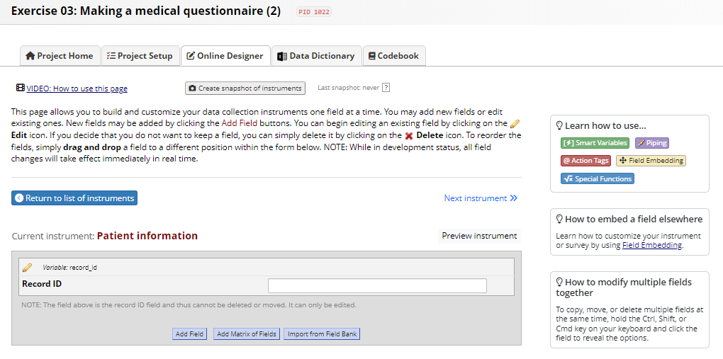

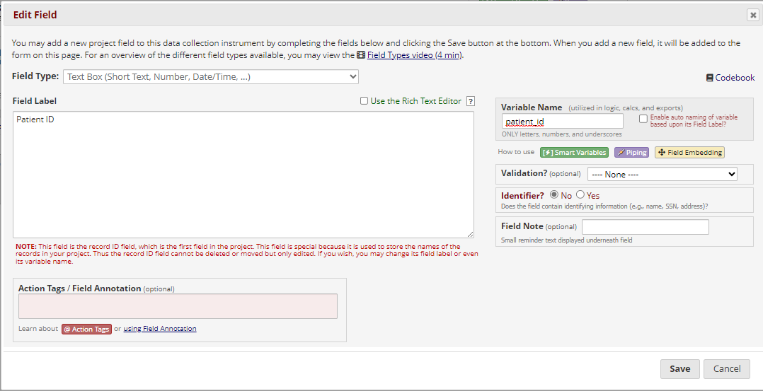

* Add a “patient_name” field

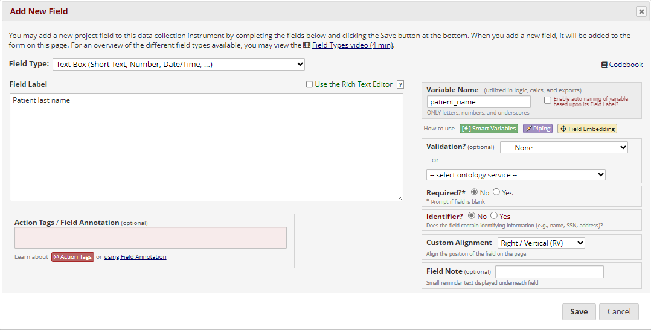

* Add a “patient_first_name” field

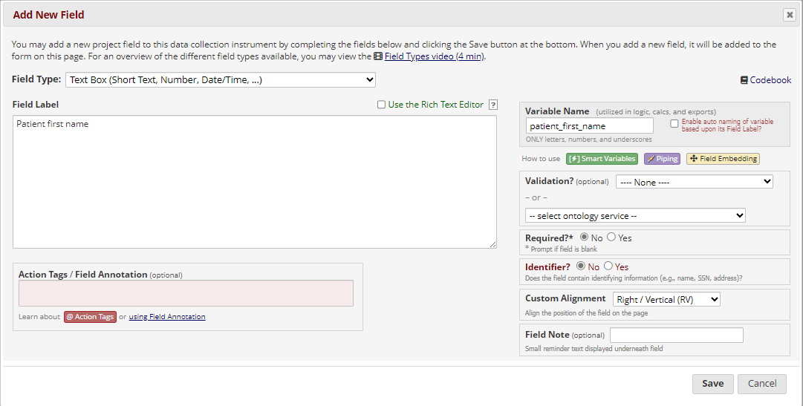

* Rename “patient_name” to “patient_last_name

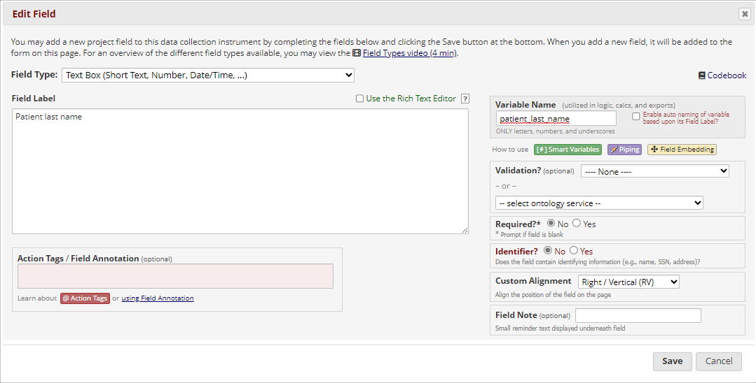

* Change the order so “patient_first_name” appears before “patient_last_name”

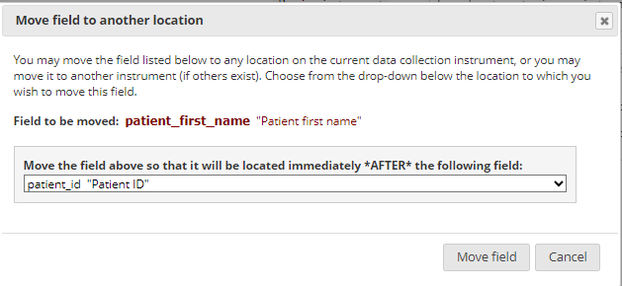

* Navigate to “Doctor visit form” and add a “visit_date” field

